### Semester One Examination, 2021

### Question/Answer booklet

# MATHEMATICS SPECIALIST

**UNIT 3**

## Section Two:

## Calculator-assumed

|  |
| --- |
|  |

Your Name

Your Teacher’s Name

## Time allowed for this section

Reading time before commencing work: ten minutes

Working time: one hundred minutes

## Materials required/recommended for this section

***To be provided by the supervisor***

This Question/Answer booklet

Formula sheet (retained from Section One)

***To be provided by the candidate***

Standard items: pens (blue/black preferred), pencils (including coloured), sharpener, correction fluid/tape, eraser, ruler, highlighters

Special items: drawing instruments, templates, notes on two unfolded sheets of A4 paper, and up to three calculators approved for use in this examination

## Important note to candidates

No other items may be taken into the examination room. It is **your** responsibility to ensure that you do not have any unauthorised material. If you have any unauthorised material with you, hand it to the supervisor **before** reading any further.

|  |  |  |  |  |  |
| --- | --- | --- | --- | --- | --- |
| **Question** | **Marks** | **Max** | **Question** | **Marks** | **Max** |
| **9** |  |  | **16** |  |  |
| **10** |  |  | **17** |  |  |
| **11** |  |  | **18** |  |  |
| **12** |  |  | **19** |  |  |
| **13** |  |  | **20** |  |  |
| **14** |  |  | **21** |  |  |
| **15** |  |  | **22** |  |  |

**Structure of this paper**

|  |  |  |  |  |  |
| --- | --- | --- | --- | --- | --- |
| Section | Number of questions available | Number of questions to be answered | Working time (minutes) | Marks available | Percentage of examination |
| Section One:  Calculator-free | 8 | 8 | 50 | 49 | 34 |
| Section Two:  Calculator-assumed | 14 | 14 | 100 | 96 | 66 |
|  |  |  |  | **Total** | 100 |

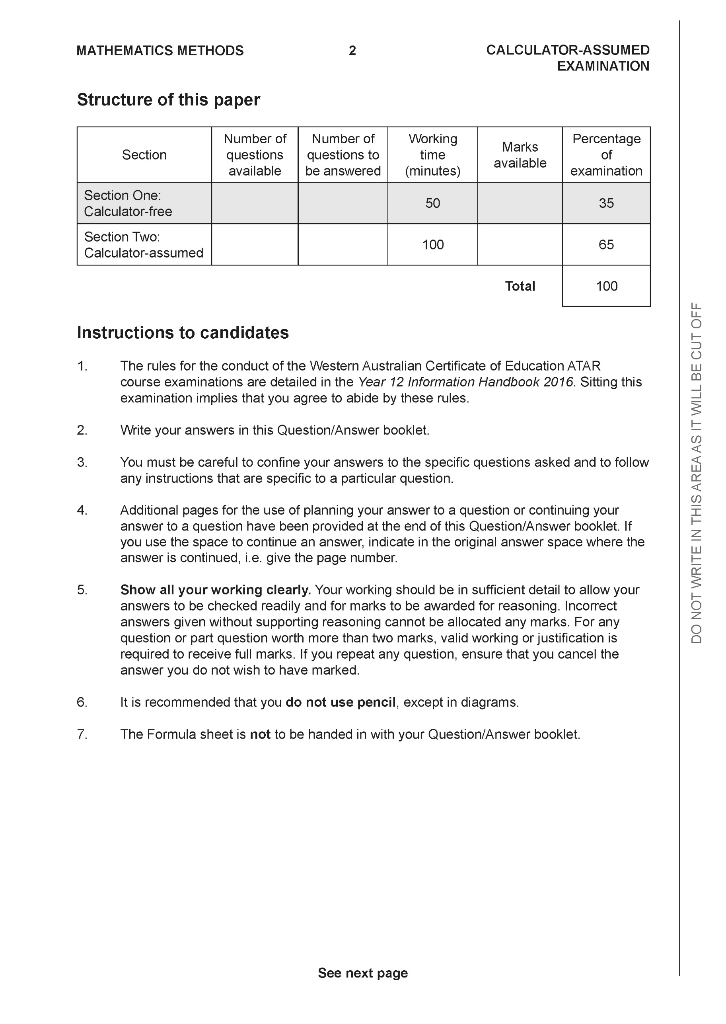

**Section Two: Calculator-assumed (96 Marks)**

This section has **14** questions. Answer **all** questions. Write your answers in the spaces provided.

Spare pages are included at the end of this booklet. They can be used for planning your responses and/or as additional space if required to continue an answer.

● Planning: If you use the spare pages for planning, indicate this clearly at the top of the page.

● Continuing an answer: If you need to use the space to continue an answer, indicate in the original answer space where the answer is continued, i.e. give the page number. Fill in the number of the question that you are continuing to answer at the top of the page.

Working time: 100 minutes.

**Question 9 (6 marks)**

1. Sketch the locus of the equation  on the axes below. (3 marks)

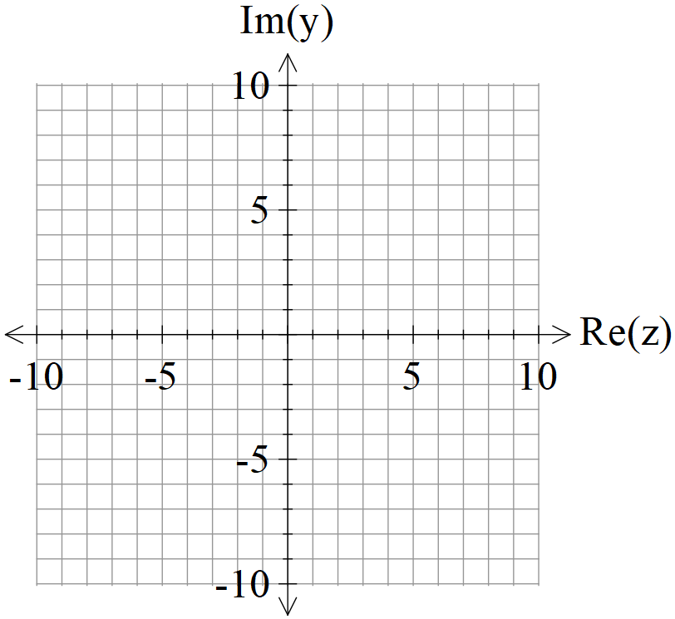

1. Determine the cartesian equation of this locus in terms of . (3 marks)

**Question 10 (9 marks)**

Consider the locus  as graphed below.

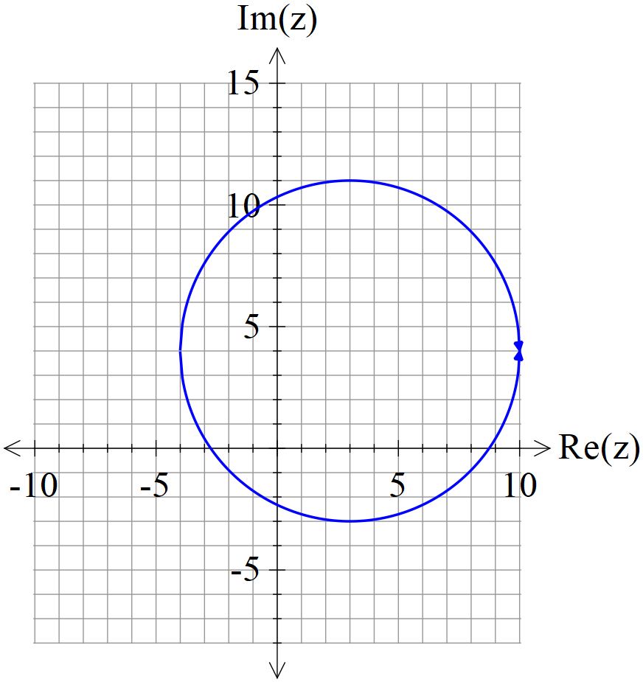

Determine the following.

1. Maximum value of . (2 marks)
2. Minimum value of  (3 marks)
3. Sketch the region defined by and on the axes above stating the coordinates of all boundary points. (4 marks)

**Question 11 (6 marks)**

Consider the line  and the point A.

1. Using **scalar dot** product show how to find the closest distance of point A to the line above.

(3 marks)

1. Using vector **cross** product show how to find the closest distance of point A to the line above.

(3 marks)

**Question 12 (9 marks)**

Consider the sphere  with  being a positive constant and the line .

Determine all possible values of ,(2 decimal places) for the following.

1. The line does not meet the sphere at all.
2. The line just touches the sphere at one point only.
3. The line meets the sphere at two points.

**Question 13 (4 marks)**

Consider a prism where each side is a parallelogram with opposites sides congruent.

The units given are in metres.

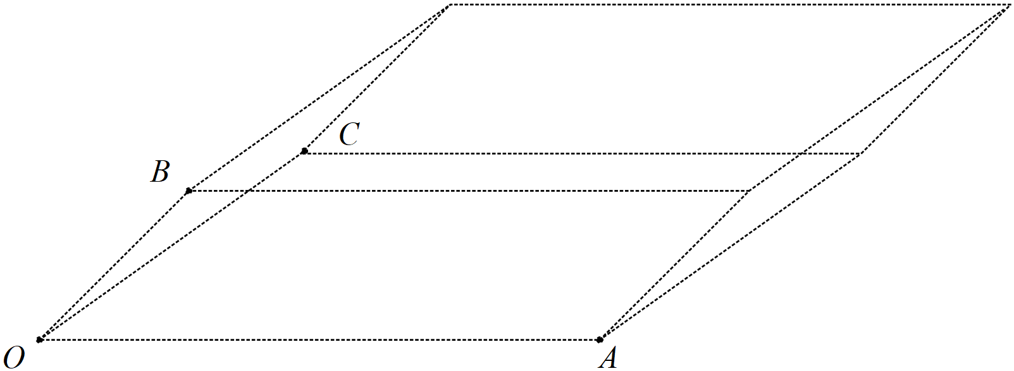

Given that  and **using vector** methods, determine the volume of the prism. (Hint: Volume = area of face multiplied by perpendicular width)

**Question 14 (9 marks)**

Consider the plane  .

1. Determine the distance of point A from the plane . (4 marks)
2. Determine an expression in terms of  for the distance of point P from the plane . (3 marks)
3. If point Ais on a plane parallel to , determine a vector equation for this parallel plane. (2 marks)

**Question 15 (7 marks)**

Consider two submarines A & B moving in deep ocean with constant velocities  .

At 12:30am submarine A is at position  and at 1am the same day

submarine B is at position .

1. Determine the time of day, to nearest minute, that the submarines are closest to each other stating this distance to the nearest metre, (4 marks)
2. If both submarines leave a lasting water trail of bubbles, determine if the trails cross and if they do at which position under water. (3 marks)

**Question 16 (5 marks)**

Consider the complex numbers  such that:



Determine  in the form  where  are real numbers.

**Question 17 (11 marks)**

Consider the 3D object  as drawn below with  the origin and 

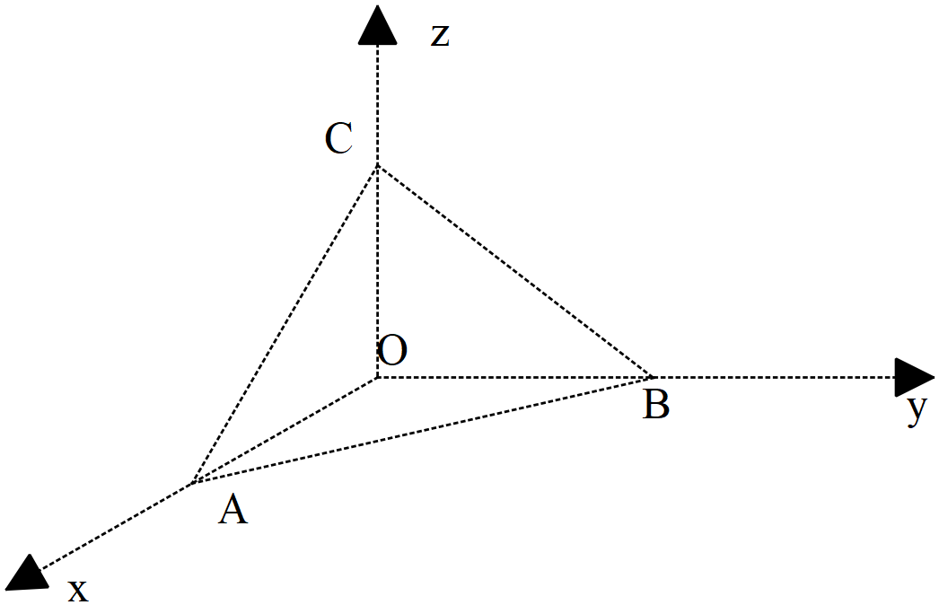

1. Determine the vectors . (2 marks)
2. Determine to the nearest degree the angle  (2 marks)
3. Determine the exact area of triangle  using vectors. (3 marks)
4. Determine the cartesian equation of the plane containing triangle . (4 marks)

**Question 18 (7 marks)**

Consider the vectors 

1. Determine  given that  are parallel**, ** is perpendicular to  and  is perpendicular to **.** (4 marks)
2. Given that , determine a vector parallel to  but equal in magnitude to .

(3 marks)

**Question 19 (7 marks)**

1. Consider the cartesian equation . Describe what this locus of points represents and state major features and give the **vector** equation.

(4 marks)

1. Consider the equation  where  is a constant. Determine the values of  for which the equation would be a sphere giving the centre and radius in terms of . (3 marks)

**Question 20 (6 marks)**

Let  be a complex number such that  and  .

1. Express in terms of  the complex number  . (Simplify) (3 marks)
2. Express  in terms of . (3 marks)

**Question 21 (4 marks)**

Consider the polynomial  where  are real constants.

Given that  and  determine the values of .

**Question 22 (6 marks)**

1. Using De Moivre’s theorem, derive an expression for  in terms of  only.

(3 marks)

1. **Using** the result from (a) above, show how to obtain **all** solutions to  in the form . Express possible values of  in **exact** form.

(3 marks)

**Working out space**

**Working out space**

**Working out space**

**Working out space**